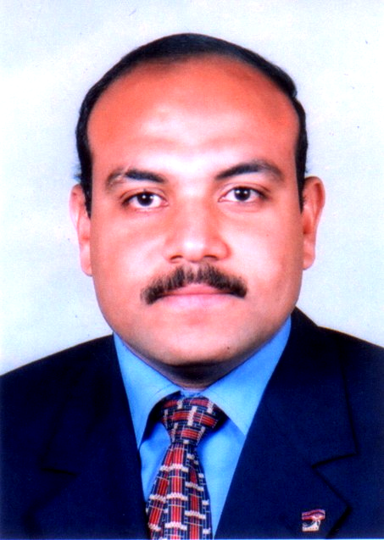
personal data CV

Assistant prof
Name : Tarek Salah Aldein Sayed Mustafa.
Date of birth : September 15, 1973.
Hand birth : obsession. Address : Assiut governorate-u Martyr Mohamed Kamel Home number (71).
Working title : Assiut University College of Education _ _ Sports Training Section and the sports science movement. Nationality : Egyptian.
Religion : Muslim. Marital status : Married.
Phone home : 020882344738
-mobile phone :-020163969086
Second : Education : Bachelor of

1-sports education :-
appreciated in a very good College of Education-Sports-Assiut University in 1996.
2-MA in sports education :-
a message entitled "Characterization of Elkinmatekeh Hara correction fly ball in the hands" of the College of Education sports-Assiut University, in 2001.
3-doctorate in physical education : _
a message entitled Bliomitri training program "for the development of muscle power and its impact on some variables Dynamic skill correction reunification in Handball -from the College of Education sports-Assiut University in 2005.

Third : prizes :
1 - was awarded the prize for best four teams in the Champions Shahid between Egyptian universities for the tennis team for 2005. He holds a
2-cup ranked second round of the sectors of Egyptian universities to team tennis and organized by the University of Assiut in 2006.
3-awarded the best research in the field of sports training and mechanics vital the International Academy of Sports Science from the University of Sofia (Bulgaria).
4-awarded the Certificate of Appreciation from the status of quality assurance and accreditation appreciated privilege for the university year 2007-2008.
5-Recipient of first place in sports activity to a game of tennis Assiut University

Fourth : career progression :

1-Assistant Professor Faculty of Education sports _ _ Assiut University in 1996.

2-Associate Professor Faculty of Education sports-Assiut University in 2003.

3-teacher-training department and sports science movement Faculty of Education sports-Assiut University in 2005.

Fifth : training courses :

1-university teacher preparation session held Assuit University in 1996.

2-cycle in the statistical program of Social
Sciences (SPPS)

3-English language courses TOFEL 2005

4-obtain a certificate of international
leadership to lead the computer ICDL 2007

5-development courses FGF-effective presentation skills. - Effective communication. - Legal aspects universities. Teaching-effective. - Design decisions-thinking skills.

6-He holds a motor cycle analysis using computer from the International Dart fish)) from Alexandria University in 2005.

7-Recipient of the "university teaching strategies effective" in the PAD University Faculty of Education--Ain Shams University in Cairo

Sixth : teaching and scientific expertise :-teaching materials were as follows :
1-Games small-college sports education-Assiut University
2-taught tennis-Education College Sports-Assiut University.
3-teaching specialization tennis-Sports Education College-University of Assiut
4-overseeing the internal process-Education Education College Sports-
5-Assiut University of Education overseeing the process of Foreign Affairs College of Education-Sports-Assiut University
6-taught knowledge of the principles of the movement-Education College Sports-Assiut University.
7-teaching science movement-Sports-College of Education University, he taught
8-analysis-motor Education College Sports-Assiut University.
9-teaching of mica-Nice vital Education College Sports-
10-Assiut University overseeing the training ground for students of the College of Education students and sports-Assiut University
11-participate in the organization of the Festival Youth Week Egyptian universities for the 2003
12-team trained university tennis girls in 2002 - 2003.
13-university team has trained tennis boys 2003 - 2006.
14-team college has trained boys 2001 : 2006-
15 participated in numerous activities Applied Faculty of Education sports-Assiut University
16-Chairman of the Faculty of Education Academic Guidance sports-Assiut University's
17-member Section mistrust sports science and sports movement Faculty of Education-Assiut University
18-participation exams work Faculty of Education sports-Assiut University
19-member band's first Pkinterol 2006 Faculty of Education sports-Assiut University
20-participate in the organization of the ceremony honoring the Faculty of Education graduates sports-Assiut University to pay 99 / 2000
21-member committees acceptance tests College sports education-Assiut University.
22-overseen a number of alcohol Seminar Faculty of Education sports-Assiut University.
23-overseen a number of public service projects to beautify the governorate of Assiut.
24-supervising her doctorate (incoming Yemeni) in 2006.
25-League championship matches observer of the game volleyball (students) for 2006.

Seventh : public activities :-

1-records Leaders Preparation Institute governorate of Sohag city.

2-decision of the technical committee and trained Egyptian Soccer Federation labor-area Assuit

functions :-

Training programs within the region

1 - the training of trainers and leaders in order to develop their abilities and skills-overseeing the sports teams, especially volleyball inside Assiut governorate-providing numerous lectures under the auspices of the Egyptian Federation tennis instructors

2 - preparation, planning and contribute to the implementation of training programs.

3-participated in the organization of Egypt Cup tennis in 2006.

4-Youth served as Secretary of the National Democratic Party.

5-supervised committees for the presidential elections in 2005.

6-supervised elections of the People of 2006.

Eighth : local and international conferences :-

1-International Scientific Conference of Sport Egyptian and the Arab world about the prospects for the Faculty of Education-Sports-Helwan University in 1998.

2-participated in the international conference to examine the scientific IV of Sciences sports Hashemite Kingdom of Jordan in 2006.

3-Elhoudouroualemsharch research at the International Conference Second Scientific Sports Academy of Sciences International Floating sports State Sofia of Bulgaria in 2006.

4-Attendance and participation in research Third Annual Scientific Conference of Sport and the Law of the University of Assiut in 2007.

Ninth : Scientific Production : A-scientific research : the title

1-confrontational exercises to rehabilitate the ankle and knee Articulator of tennis players Assiut Governorate.

2-impact training boat on some variables and their relationship to the physical variables Albayoumikanekeh performance-pointers in tennis.

3-Draft Genetics impact on some sporting activities in the Arab Republic of Egypt.

4 - problems arising from the monopoly of broadcast media (encryption) and its relationship to the Egyptian law field study

